Name: Pranali Sonawane
Subject: MCSA
Date: 07-01-2026
Lab 21: Remote Desktop and Add Network Adapter and Install Remote Access

- Remote Desktop
Server1:
Requirement : First Ping for all Machine 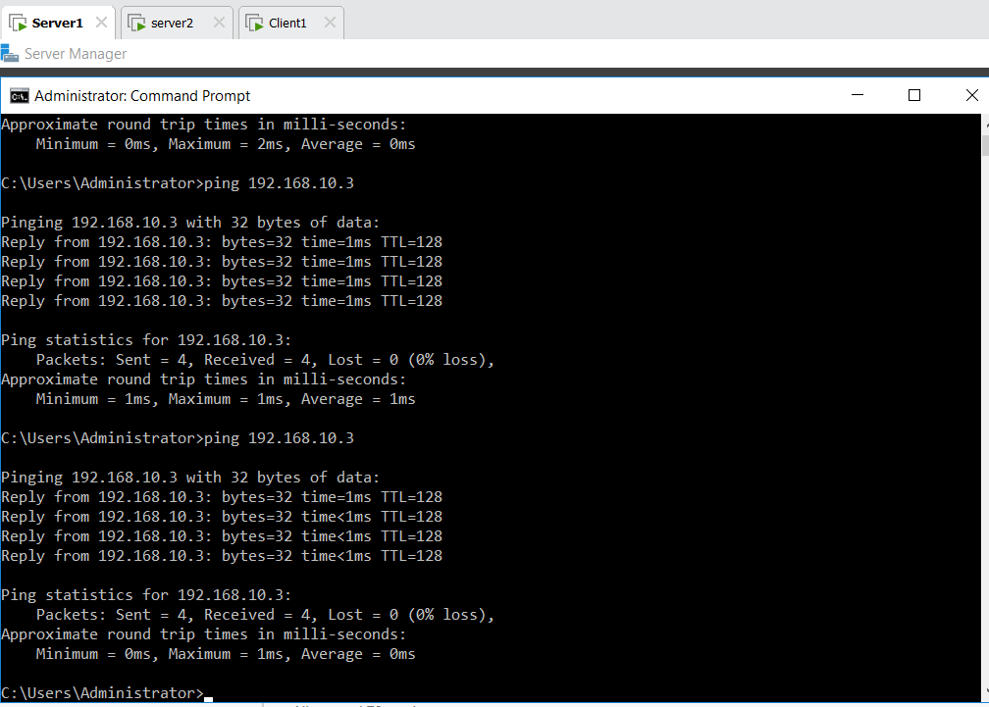
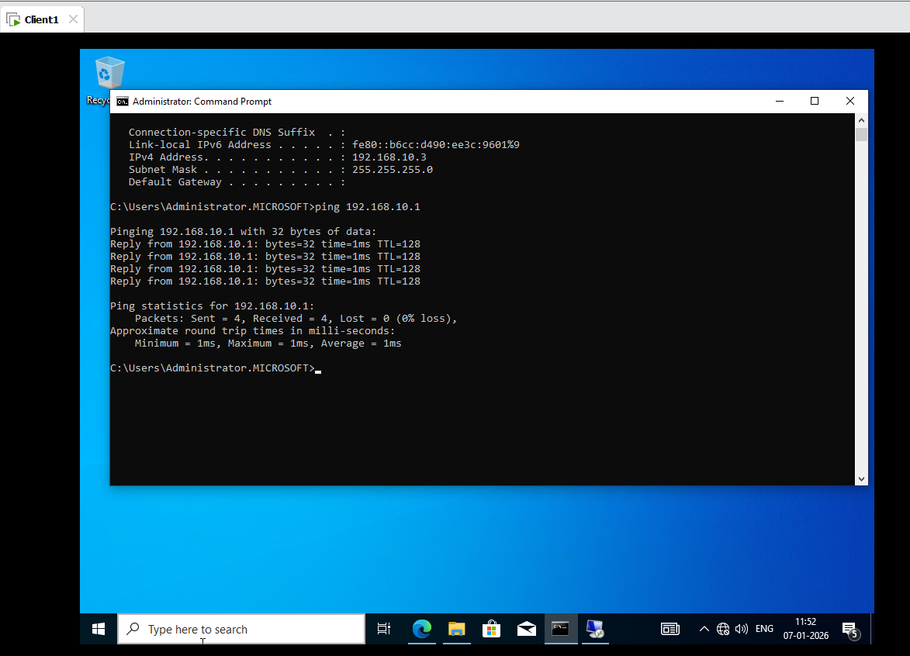
Server 1:
This PC Right Click on Properties Remote Settings Allow Remote Connections to this Computer Not Click on Checkbox Apply Ok
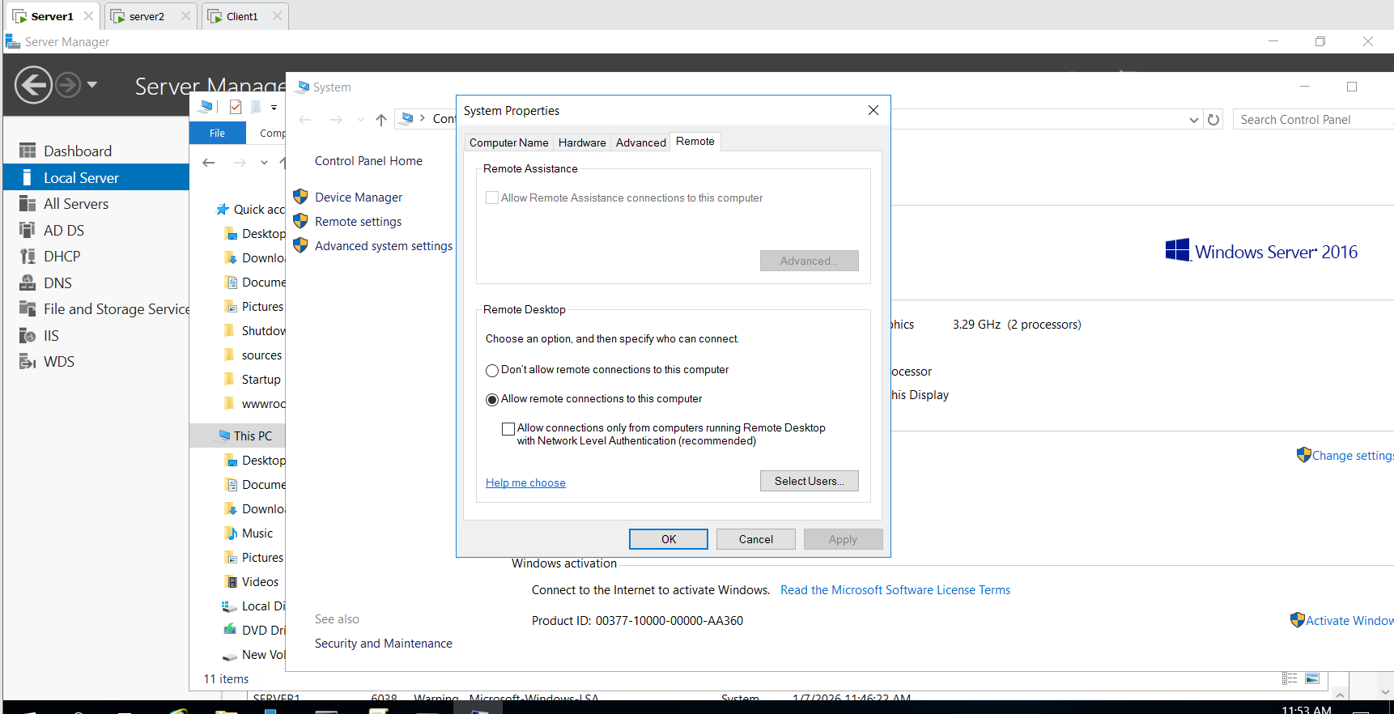
Client 1 :
Type here to Search Remote Desktop Connection
Type IP Address (192.168.10.1) give Password(Password@123) yes Client 1 Desktop in Server 1 Access Remotely.
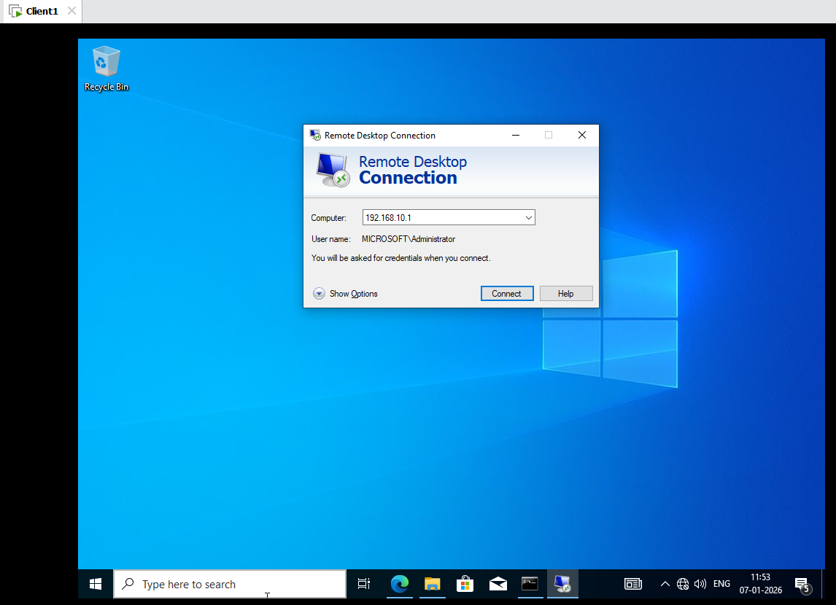
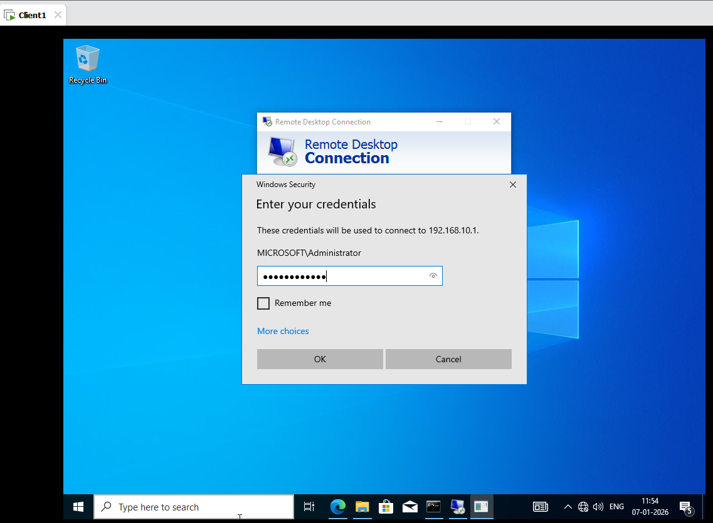
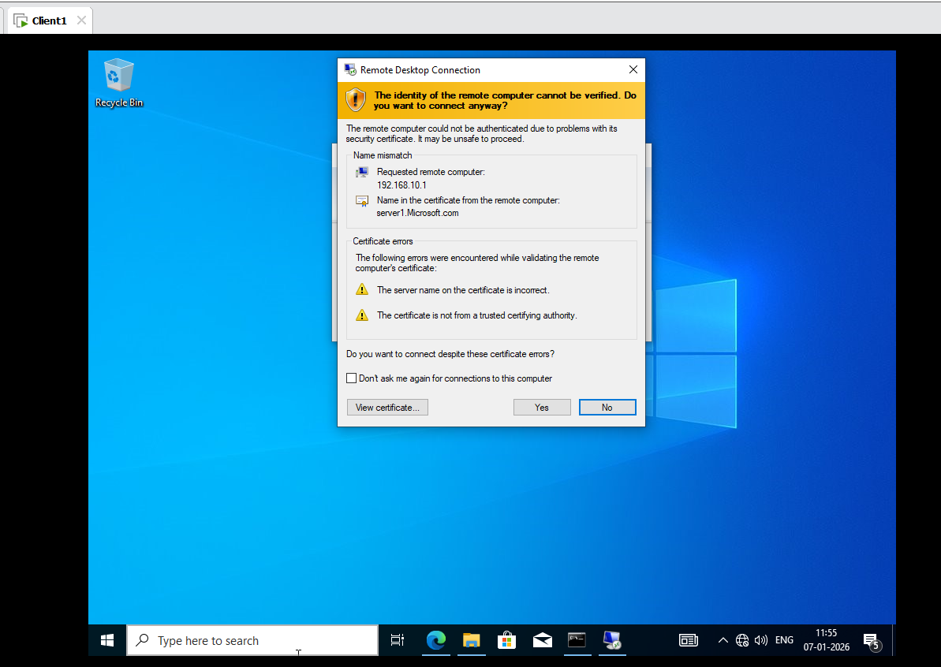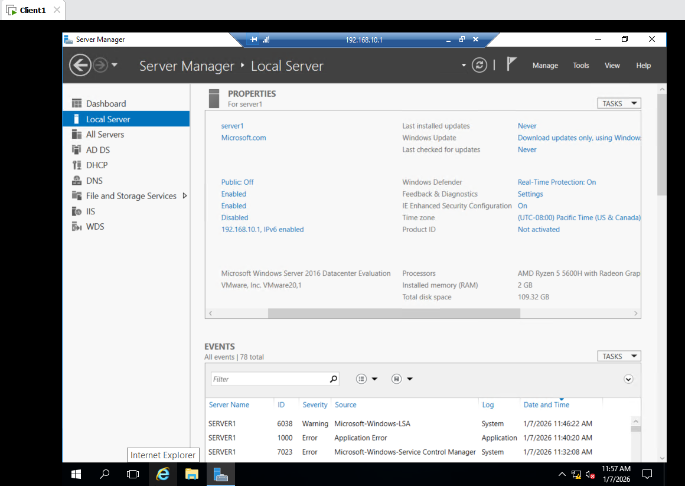

- Add Network Adapter Card in Client 1 and Server 1 :

Server 1:
Edit VM Settings New Adapter Add Select Custom in that vmnat4 ok
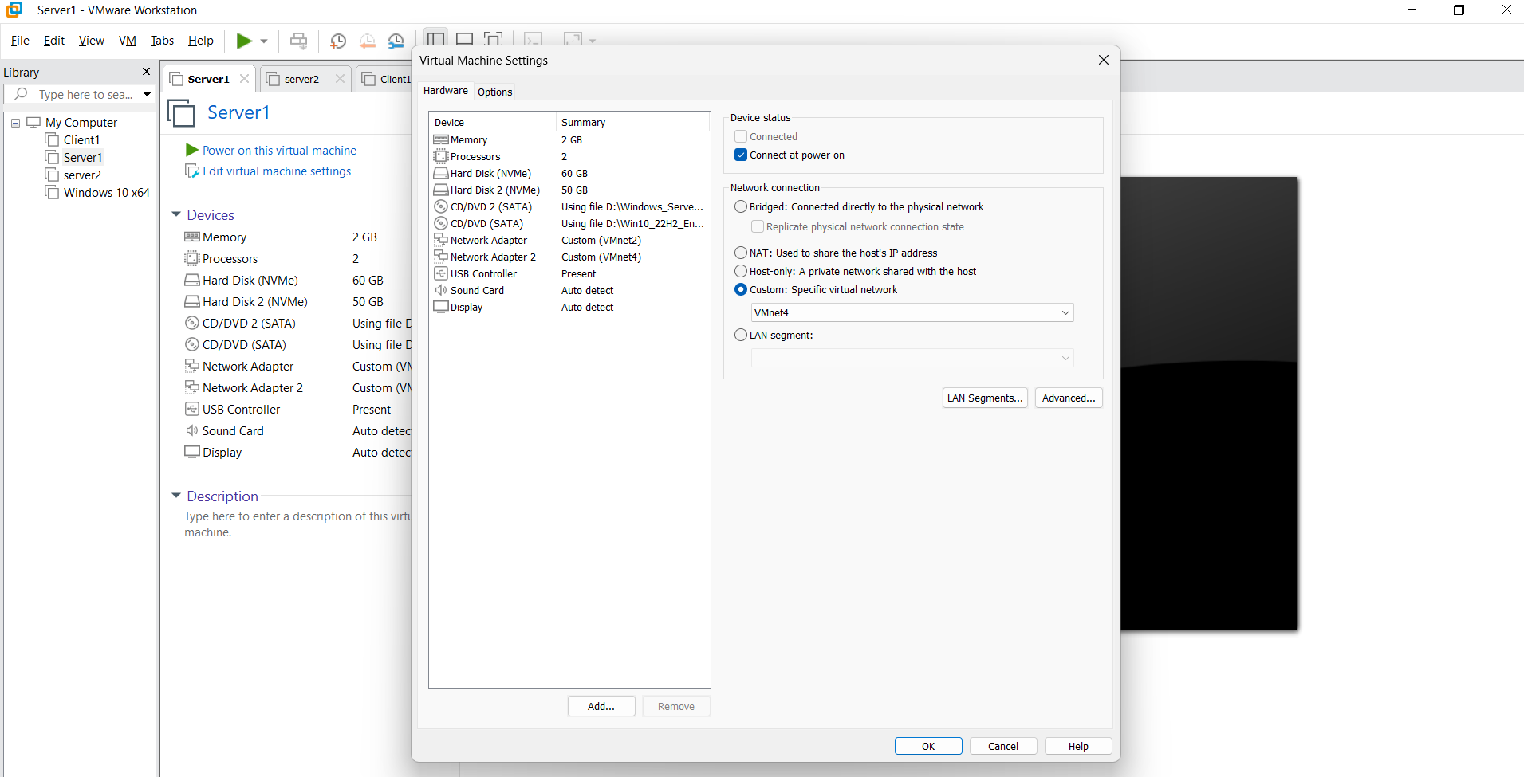
Search Control Panel Network and Internet Network and Sharing Center Ethernet1 IPV4 Give ip Address 1.1.1.1
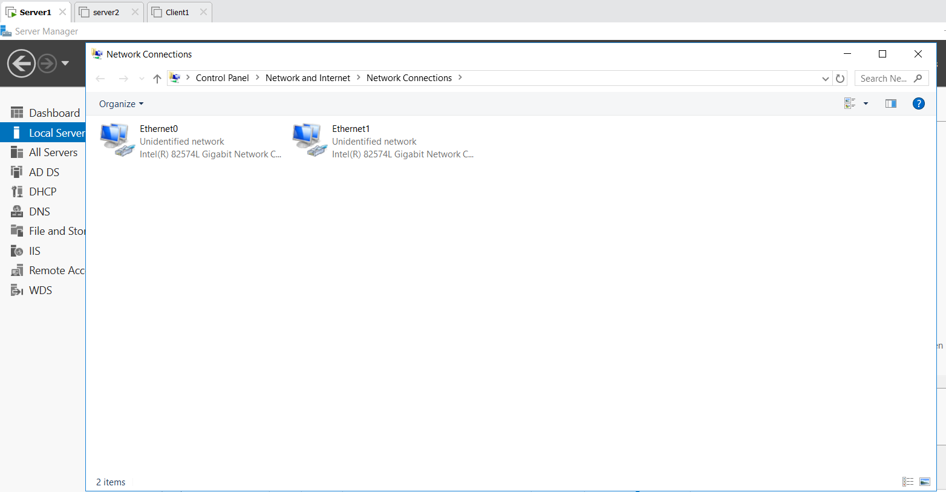
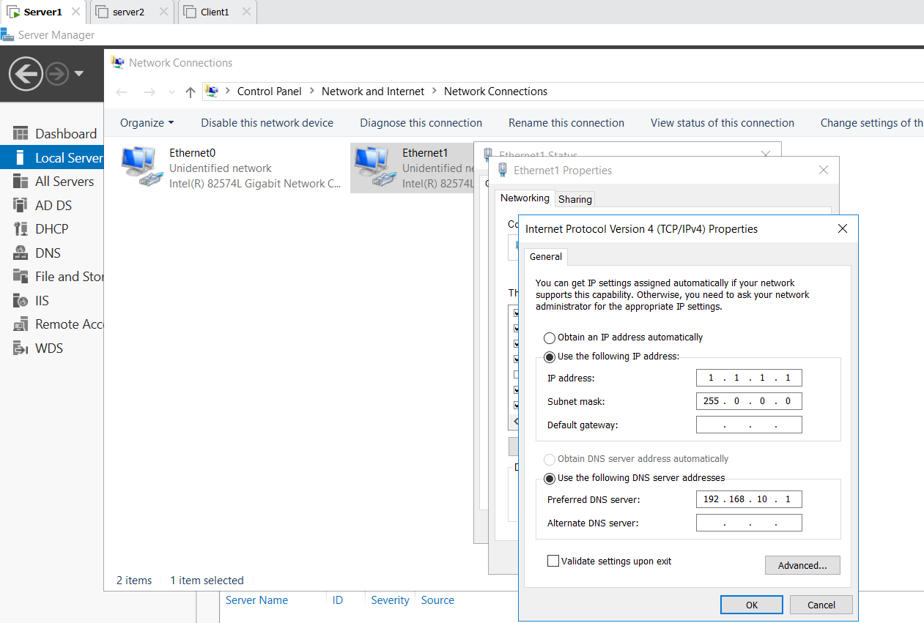
Server 1 :
Cmd ping 192.168.10.3
Ping 1.1.1.1
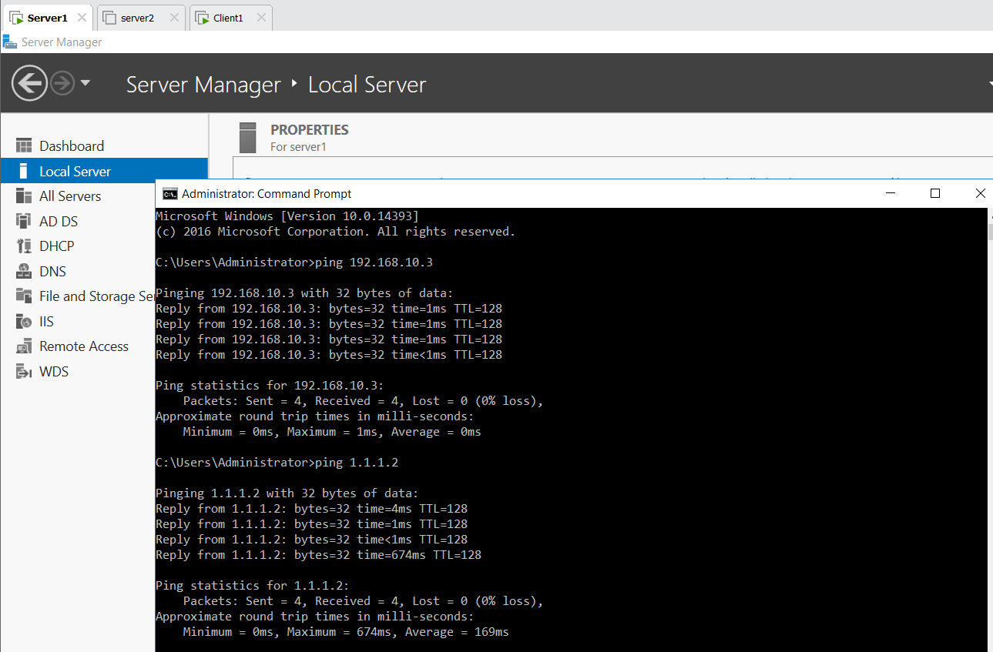
Client 1:
Edit VM Settings New Adapter Add Select Custom in that vmnat4 ok
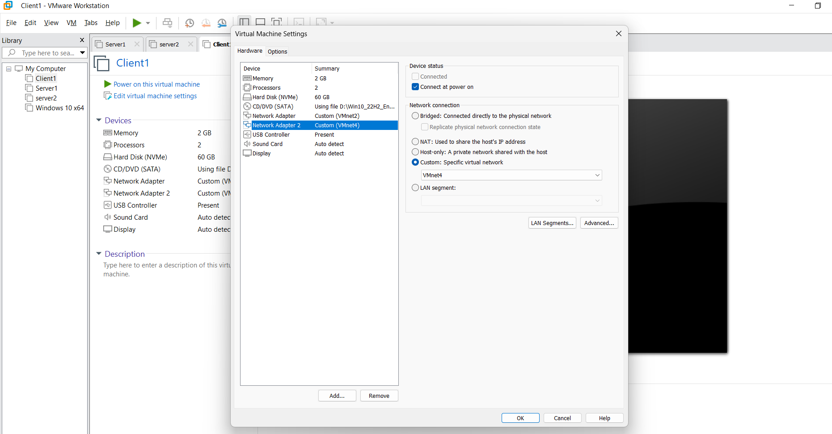

Search Control Panel Network and Internet Network and Sharing Center Ethernet1 IPV4 Give ip Address 1.1.1.2
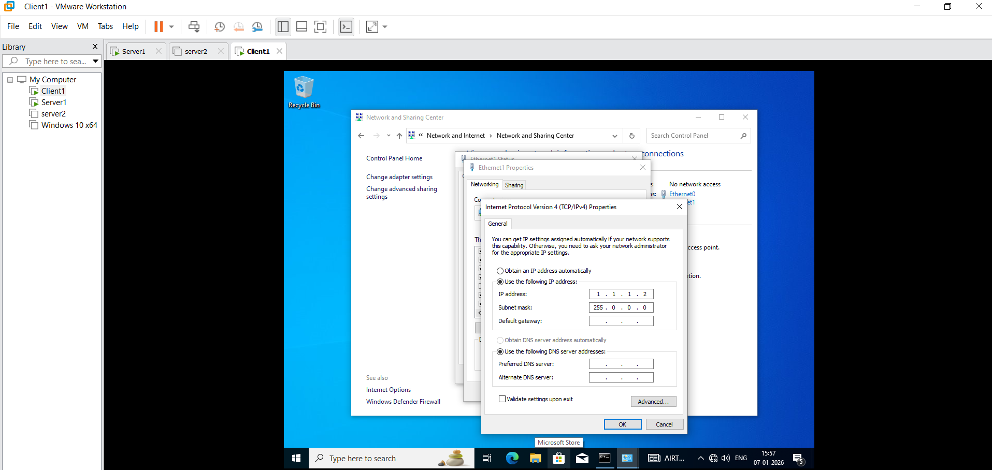

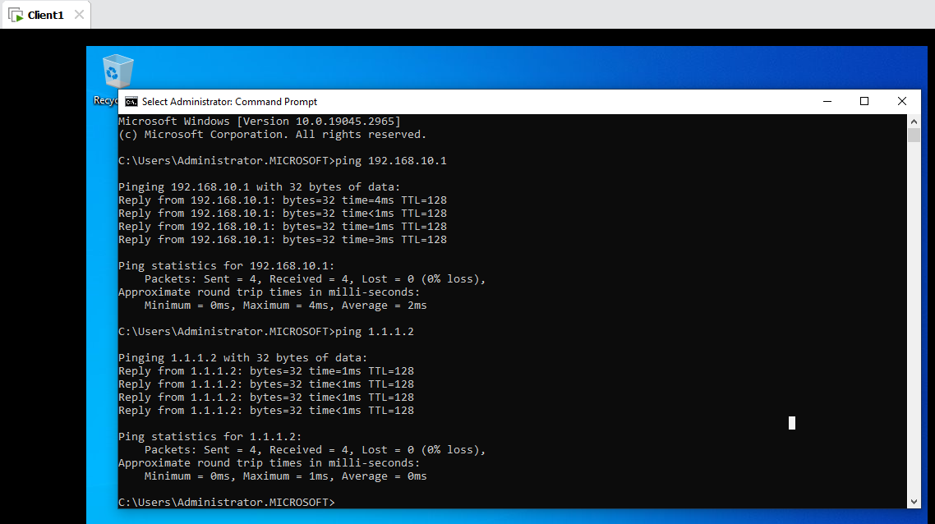

- Install Remote Access
- Install Remote Access: Dashboard Add roles and Server next next Remote Access Select 3 DirectAccess and VPN ,Routing,Web Application Proxy install.
